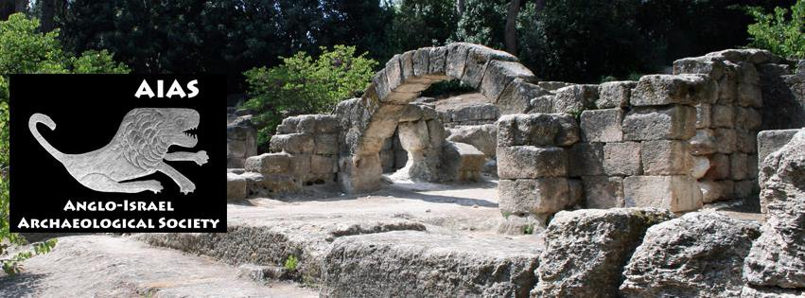
Strata:
Journal of the Anglo-Israel Archaeological Society

Instructions for Authors

The following guidelines are designed to help you prepare your manuscript for submission to Strata.

- JOURNAL SCOPE AND PUBLICATION CRITERIA

Strata is an annual peer-reviewed journal that publishes to a high academic standard. Our scope is the archaeology of Israel and neighbouring territories; further information may be found in our Peer Review Policy (http://aias.org.uk/peer-review-policy/).

Papers must be original and written in English. The editors will not normally accept articles for publication which have appeared in substantially the same form elsewhere, whether in English or in another language. Strata will also not accept papers that are currently under consideration for publication elsewhere, or are being prepared for another publication. Authors are expected to adhere to the requirements of the AIAS publication ethics policy (http://aias.org.uk/publication-ethics-policy/), and only use data that has been obtained in a legal and ethical manner.

- PREPARING YOUR PAPER FOR THE SPECIAL WORKSHOP ISSUE

2.1 Submission length

Articles should be up to 8000 words in length, not including bibliography. Reviews of individual books should be between 500 and 800 words; reviews covering multiple publications should be between 1000 and 2000 words.

2.2 Text formatting

Text should be single-spaced, in 12-point Times New Roman font, and supplied as a Microsoft Word document, labelled with author name/s and short title. This document should include an abstract, author(s) affiliations, keywords, and bibliography. Image and table captions should be provided as a separate MS word file.

2.3 Referencing

References within the article should follow the Harvard system, e.g.: (Brown 1974: 116), with an alphabetically ordered bibliography at the end of the paper. Please format this according to the rules in our Strata Style Guidelines.

  - Style guidelines

Submissions should follow the Strata Style Guidelines, which are available from the AIAS website (https://aias.org.uk/wp-content/uploads/2023/05/Strata-style-guide-for-authors_v4.docx).

2.5 Image preparation

All maps and plans should include a scale and a north arrow.

Illustrations should take the form of individual TIFF or JPEG files, at 300 dpi resolution for colour images, 600 dpi for greyscale images, and 800-1200 dpi for line drawings. Images that do not meet these minimum requirements may not be published. Where possible, submit illustrations in a form close to the intended published size. Tables should be prepared in Microsoft Word, with each table appearing as a separate document.

Image files should be labelled with the lead authors surname, then a suffix indicating the figure or table reference; figures and tables should be numbered separately (e.g.: Smith_fig01, Smith_table 01). Supply captions for each in a separate Microsoft Word document, including credit lines or copyright information where appropriate.

Any desired groupings, sizing and scale reductions of images should be indicated where possible; otherwise images will be arranged at the editors' discretion. The editors reserve the right to ask for a reduction in the number of illustrations, or for additional images to be supplied, where this seems appropriate.

2.6 Copyright

It is the author(s) responsibility to ensure that they obtain in writing the appropriate copyright permissions for use of any material in their work, including images; that they are not in violation of intellectual property rights; and that copyrighted material is appropriately credited in their manuscripts, as mentioned above. Authors are expected to pay any costs for obtaining appropriate permissions themselves. If the author is the copyright holder, then this should be made clear in the paper (e.g.: state it is the 'author's image'). Strata will require permission to reproduce this material in all formats, including digitally, worldwide, and in perpetuity.

The copyright of all published articles in Strata belongs to the Anglo-Israel Archaeological Society, apart from photographs or diagrams which are the property of the author(s) and/or third parties, for which a copyright designation such as 'copyright [named holder]' should be appended to the relevant figure captions. After an embargo period (currently three years), the author(s) will be permitted to post their articles online and freely distribute copies.

  - Author contributions

It is expected that all authors named on a manuscript will have made some significant contribution to the research, and a short statement indicating contributor roles should be supplied to the editors — for example, indicating who collected the data or supervised/performed analyses on it, who provided resources to facilitate the research, and who wrote the manuscript.

  - Declarations of interest

Authors should disclose any sources of financial support for their research, such as grants and other sponsorship, and indicate if they have any potential competing interests.

- SUBMITTING YOUR PAPER

Article submissions should be emailed to the editors, Professor Ken Dark and Dr Rachael Sparks, at AIAS-strata@hotmail.com. Book reviews should be sent to Rebekah Welton at reviews.strata@gmail.com.

3.1 Submission checklist

Articles should include the following elements:

- Title.
- Author’s name and affiliation.
- An abstract of 150–200 words.
- 5-10 keywords.
- Article text, formatted using the style guide provided.
- Bibliography (only include works cited in the article).
- List of figure and table captions, where relevant.
- Image files, to be sent as separate files, not embedded in the manuscript. We recommend you send them via a programme such as Dropbox or WeTransfer, rather than via email.
- A brief statement to the editors indicating how each author has contributed to the submitted manuscript.
- Disclosure of competing interests, or a statement that there are no competing interests.

- EVALUATION AND PEER REVIEW

Authors should consult the AIAS Peer Review Policy for full details of evaluation procedures (http://aias.org.uk/peer-review-policy/). If revisions are requested, authors should take care to respond fully to all points raised and indicate clearly where their resubmitted manuscript has been revised.

Authors will receive a pdf copy of the first page proofs of their submissions; it is their responsibility to check this carefully and advise the editors of necessary corrections promptly. Rewriting of text is not possible at this stage; corrections should be limited to small factual and typographical mistakes. The editors will be responsible for any subsequent proof copies.

- AFTER PUBLICATION

Authors will receive a pdf file of their published article; copies may be made for reasonable personal use. The pdf may not be used for commercial purposes, or posted online, until an embargo period has passed (currently three years). Authors will also receive a free pdf copy of the current journal issue; this is for personal use only and may not be redistributed.

Book reviewers receive a complimentary copy of the book under review (which may be in hard copy or electronic format), and a pdf copy of the book reviews section from the relevant issue of Strata. Until the review is received by the Reviews Editor and accepted for publication, the book remains the property of AIAS and may be liable to be returned at the expense of the recipient.

Any reproduction from Strata, apart from for the purposes of review, private research or 'fair dealing', must have the permission of the Anglo-Israel Archaeological Society. Requests for such permission must be addressed to the editors of Strata, at AIAS-strata@hotmail.com. In all cases, acknowledgement must be made to Strata.

- QUALITY CONTROL

The editors will be alert for signs of research misconduct in submitted work, and take appropriate action where research misconduct is suspected or identified, following the procedures recommended by the Committee on Publication Ethics (COPE) (see https://publicationethics.org/guidance for details). This includes taking appropriate steps should misconduct be identified after publication has taken place.

Authors are expected to respond to the detection of errors in their published work by providing retractions, clarifications, corrections, or apologies, as appropriate, which will be published in a subsequent issue of the journal.

Strata: Bulletin of the Anglo-Israel Archaeological Society
Last updated: 29 May 2023

